VALHALLA VOICE: August 31, 2020
The Valhalla Voice is the newsletter of the many Mt. Hebron parent groups including: the PTSA, which includes the Chinese, Korean, Indian, and Latin American committees; Parents of African American Students (PAAS); the Viking Backers Booster Club; and Marching Unit Booster Club.
Parent Teacher Student Association (PTSA)
Caroline Bodziak, President: president@mthebronptsa.com
Website | Facebook | Twitter
Meetings 2nd Tuesday @ 7pm via Zoom (except September is Thurs., Sept. 17)
8/27 Meeting Results
Welcome and congratulations to new Executive Board members Erinn Camp-Mansour as 2nd VP and Vanessa Smith-Lang as Recording Secretary. Click here to review the draft August meeting minutes and see the results of all the votes.

Next PTSA Meeting
Thursday, September 17 @ 7pm via Zoom. This will be an informational meeting with Dr. Miller following the 9/9 Back-to-School night presentation and the first two weeks of virtual school. Check the PTSA website for updates.

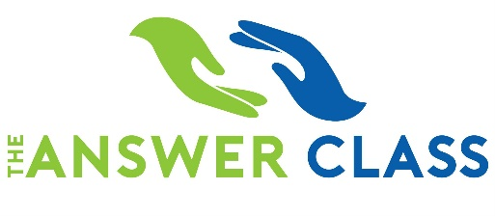
Upcoming SAT Prep Classes
Sat./Sun. Oct. 10 & 11 from 9am-1pm both days
AND
Sun., Nov. 8 from 9am-1pm + T/Th Nov. 10-11 from 7-9pm
Register with The Answer Class now only $149.

United Way Campaigns
If your business conducts a United Way Campaign you can designate Mt. Hebron PTSA as a recipient of some of your contribution using designation code #166. Thank you!

Thank You
To the Hospitality Committee, Staff Appreciation Committee, and parents who generously donated to gifts and snacks distributed to Hebron Staff at the 8/29 Staff Drive-By. See photos on the PTSA Facebook page and on the website.

Worth Repeating….
One Book, One School for Parents/Community
A Collaboration with Parents of African American Students (PAAS): Students, Staff, Parents and Community Members are invited to read a common book and participate in activities throughout the year to lead to informed action. The selected book is “Stamped: Racism, Anti-Racism, and You” by Jason Reynolds. Interested parents and community members sign up and learn more here. Students and staff will learn more through school.

Join Today
Your membership is THE MOST IMPORTANT THING you can do for PTSA so don’t wait, join now! Explore the website to learn about everything the PTSA does to support ALL students, staff, and families at Mt. Hebron. Click on the image to join.

- Chinese American Parent and Student Committee (CAPSA)
Daisy Zhang, Chair: capsa.mhhs@gmail.com, www.capsamhhs.weebly.com
- Korean American Student Parent Committee (KASPO)
Il Minn, Chair: iminn1@gmail.com
- Indian American Student Parent Committee (IASPA)
Gopi Suri, Chair: gopi_suri@yahoo.com
- Latin America Council Committee (LAC)
Liset Rajaratnam, Chair: lisetraj@yahoo.com

Mount Hebron Marching Unit Boosters (MTHMU Boosters)
Helen Morse, President: http://mthmarchingunit.wixsite.com/boosters
Parents of African American Students (PAAS)
Co-Presidents Juliet Yeates-Trotman & Adrienne Brown mthebronpaas@gmail.com
$30/family – Join online www.mthebronpaas.wixsite.com/paas
Viking Backers
Jim Bahel, President: president@vikingbackers.org, http://www.vikingbackers.org/
While 2020 might start off different than the past, we plan on ending the year on a high note!
Your membership this year is more important than ever! Please consider being a Backer for the coming school year. We have launched a new website to make it easier for you to join. Hover your phone camera here to be directed to our membership link…

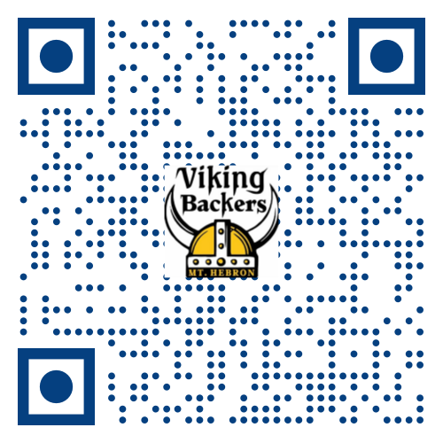

SPIRITWEAR SALE ENDS TONIGHT 8/31! Show your school spirit with Hebron apparel & more!
https://www.bsnteamsports.com/shop/MTHSPIRIT

NEXT MEETING IS SEPTEMBER 14, 2020 at 6:30pm via Zoom. Please email president@vikingbackers.org for the link.

Community News
Be an Emotional Support Human
More than ever, your friends, loved ones, and community need you. A small effort can make a big difference. Emotional Support Humans show a willingness to reach out and listen compassionately for loved ones living with anxiety, depression, and other mental health challenges. Learn more about how you can be an Emotional Support Human here. Sponsored by Horizon Foundation.

For Parents of Seniors
Two new Facebook groups for info sharing among parents and guardians: Mt Hebron Parents/Guardians of 2021 Seniors and HoCo Class of 2021 Senior Parents. Both are private groups NOT sponsored by PTSA.

