Viking Parent Weekly September 8, 2020
An email newsletter of the many Mt. Hebron parent groups.
Parent Teacher Student Association (PTSA)
Caroline Bodziak, President: president@mthebronptsa.com
Website | Facebook | Twitter
Meetings 2nd Tuesday @ 7pm via Zoom (except September is Thurs., Sept. 17)
Next PTSA Meeting
Thursday, September 17 @ 7pm via Zoom. This will be an informational meeting with Dr. Miller following the 9/10 Back-to-School night presentation and the first two weeks of virtual school. Check the PTSA website for updates.

Have Questions After Back-to-School Night?
Did Back-to-School Night leave you with even more questions? Please email them to president@mthebronptsa.com. Dr. Miller will address as many as possible at the 9/17 PTSA Zoom meeting.

Suicide Awareness & Prevention Training
Suicidal thoughts, much like mental health conditions, can affect anyone regardless of age, gender or background. People trained in QPR learn how to recognize the warning signs of a suicide crisis and how to question, persuade and refer someone to help. Register for FREE virtual training by qualified Grassroots instructors here. For youth ages 13 & up, their families or anyone who works with youth. Visit the PTSA website for additional mental health resources.

Worth Repeating….
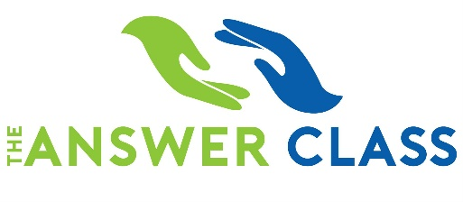
Upcoming SAT Prep Classes
Sat./Sun. Oct. 10 & 11 from 9am-1pm both days
AND
Sun., Nov. 8 from 9am-1pm + T/Th Nov. 10-11 from 7-9pm
Register with The Answer Class now only $149.

United Way Campaigns
If your business conducts a United Way Campaign you can designate Mt. Hebron PTSA as a recipient of some of your contribution using designation code #166. Thank you!
One Book, One School for Parents/Community
A Collaboration with Parents of African American Students (PAAS): Students, Staff, Parents and Community Members are invited to read a common book and participate in activities throughout the year to lead to informed action. The selected book is “Stamped: Racism, Anti-Racism, and You” by Jason Reynolds. Interested parents and community members sign up and learn more here. Students and staff will learn more through school.

Join Today
Your membership is THE MOST IMPORTANT THING you can do for PTSA so don’t wait, join now! Explore the website to learn about everything the PTSA does to support ALL students, staff, and families at Mt. Hebron. Click on the image to join.

- Chinese American Parent and Student Committee (CAPSA)
Daisy Zhang, Chair: capsa.mhhs@gmail.com, www.capsamhhs.weebly.com
- Korean American Student Parent Committee (KASPO)
Il Minn, Chair: iminn1@gmail.com
- Indian American Student Parent Committee (IASPA)
Gopi Suri, Chair: gopi_suri@yahoo.com
- Latin America Council Committee (LAC)
Liset Rajaratnam, Chair: lisetraj@yahoo.com

Mount Hebron Marching Unit Boosters (MTHMU Boosters)
Helen Morse, President: http://mthmarchingunit.wixsite.com/boosters
Parents of African American Students (PAAS)
Co-Presidents Juliet Yeates-Trotman & Adrienne Brown mthebronpaas@gmail.com
$30/family – Join online www.mthebronpaas.wixsite.com/paas
Viking Backers
Jim Bahel, President: president@vikingbackers.org, http://www.vikingbackers.org/
While 2020 might start off different than the past, we plan on ending the year on a high note!
Your membership this year is more important than ever! Please consider being a Backer for the coming school year. We have launched a new website to make it easier for you to join. Hover your phone camera here to be directed to our membership link…

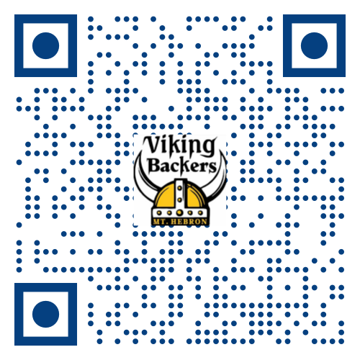

NEXT MEETING IS SEPTEMBER 14, 2020 at 6:30pm via Zoom. Please email president@vikingbackers.org for the link.
Community News
For Parents of Freshmen
A new Facebook group for info sharing among parents and guardians: Mount Hebron High School Class of 2024 Parent Group. This is a private group NOT sponsored by PTSA.

