PRINCIPAL’S NEWSLETTER
June 12, 2020

Hello Everyone,

So much transpired these past few weeks, and I’m thankful that we are experiencing everything together. We never expected to be apart these last few months, and we certainly never expected our students to witness the violent actions of racism, solidifying the fact that inequalities still exist today. Over the past week, we’ve held several student and staff meetings to come together to share our experiences over the senseless killing of George Floyd, and our students, staff, and parents are more committed than ever to making us a more inclusive school for everyone.

Because of Covid and because we have the gift of time, we can come together and discuss action items for true change. We have done so much in the last three years as a community, but we have so much more to do. Our hearts are open, and we have a foundation of trust to hold the courageous conversations that we need to have. We have an incredible staff and community who want nothing more than to unite to provide the best high school experience EVER for our students. I believe in you. I rely on you. I’m counting on you to continue to do what’s right for our students, staff, and community even when it’s hard.

There are still many unknowns about the upcoming school year, but what I do know is that we are in this together. All of us have experienced some level of change. As we know, it’s the only constant. Some of the change and challenges have been welcome. Other, we fear. However, one thing is for sure; things will not, cannot, stay the same. When a life-changing event occurs, or multiple life-changing events occur, what we can control is how we respond. We can either despair that a change has come and assume that things will be worse, or we can look toward change with excitement. Look at the new possibilities for personal growth that these new changes present.

Our staff had to embrace tremendous change over these past several months as they’ve been forced to learn a whole new way of teaching with virtual learning, and in my opinion, they’ve done a fantastic job on a very steep learning curve. They jumped right in, learned everything they could, adjusted their curriculum, and taught countless lessons looking only at a letter on a screen since many students don’t turn on their cameras. If you saw the behind the scenes, you’d see meetings over the most important concepts to cover yet presented in a way not to overwhelm the students. You’d see hours of lesson planning to make sure the students received their 1.5-2 hour assignment. You’d see staff reaching out to kids who couldn’t check-in. You’d see staff who delivered food and supplies to families struggling. You’d see our school improvement team making sure they verbally connected with all 1,705 Hebron students. You’d see the hundreds of hours our graduation team put in to make sure our seniors felt loved and valued. And you’d see staff meetings where staff wanted to maintain the rigor while allowing compassion and learning technology to best help them. And, of course, our staff was doing all of this while working from home, getting online with your students while most of them still had to deal with their own school-aged children. Thank you to the staff who let us see their children dancing and playing in the background during virtual meetings. These glimpses into your lives not only make us giggle but make us more compassionate and proves just how driven to excellence you really are as you juggle the multitude of responsibilities that have converged in your lives over these past several months.

This may be our last formal newsletter for the school year, but we will continue to provide updates as we get new information. As I reflect on the past school year, the one idea that continues to drive me is my belief in our students, our staff, our community, and our world. I truly believe that if we come together, if we remain Viking Strong, we will all do better and be better. More than ever, it’s a time to believe.

All my love,
Joelle

A Time To Believe, by B.J. Morbitzer
To believe is to know that every day is a new beginning.
Is to trust that miracles happen, and dreams really do come true.
To believe is to see angels dancing among the clouds, to know the wonder of a stardust sky and the wisdom of the man in the moon.
To believe is to know the value of a nurturing heart, the innocence of a child's eyes and the beauty of an aging hand, for it is through their teachings we learn to love.
To believe is to find the strength and courage that lies within us when it's time to pick up the pieces and begin again.
To believe is to know we are not alone, that life is a gift and this is our time to cherish it.
To believe is to know that wonderful surprises are just waiting to happen, and all our hopes and dreams are within reach.
If only we believe.

FOLLOW US & STAY CONNECTED
Twitter: @hcpss_mhhs
Website: http://mhhs.hcpss.org
Student Online Newspaper: The Mountain: https://mthmountain.com
UPCOMING DATES/EVENTS
Date | Time | Event
June 19, 22 & 23 |  | Half days for students
June 23 |  | Last Day of School for students

CELEBRATIONS!
**For even more celebrations & good news, follow us on Twitter: @hcpss_mhhs

CONGRATULATIONS to Social Studies teacher, Mr. Vann Prime, who has been selected as a University of Chicago Outstanding Educator. He was recommended for this award by his student, Aditya Krishna who was accepted into the University of Chicago Class of 2024. Each year, newly admitted students have the opportunity to select educators who go beyond everyday teaching and leave an impression that is carried over a lifetime. An Outstanding Educator thinks carefully about their instruction, shares an infectious love for learning and care for students both inside and outside the classroom. Mr. Prime makes a positive impact on his students every day, and we are thrilled to share his latest achievement! So proud of you Mr. Prime!!!

ONE MORE MASSIVELY HUGE THANK YOU to Erin Lanthier & the PTSA Hospitality Committee for once again providing breakfast for our staff who worked this past Wednesday during 9th-11th grade materials drop-off. Thank you for reaching out, for caring, for always ensuring the well-being of our staff. We don’t take it for granted!!
Thanks also go to the Viking Backers who provided snacks and drinks. To say we are appreciative is an understatement!

We are sad to say goodbye to our staff who is not returning next year. We are so thankful for all their contributions to the students and Mt. Hebron community. Although each is moving onto another experience, Once a Viking, Always a Viking!

CHERYL GRIMES
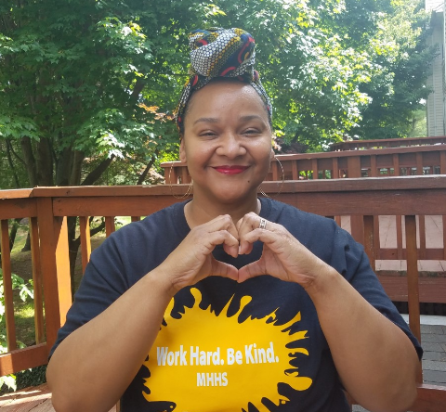
Cheryl Grimes is our Achievement Liaison and focuses on our Black Student Achievement Program. She is our sponsor for our Black Student Union and works endlessly for our students. Whether monitoring grades, teaching organizational skills, matching students & families with resources, mediating difficult conversations or being a lunch buddy, seeing the students grow has been a source of both inspiration and pride for Mrs. Grimes. She always provided safe spaces providing an open ear to black students who often feel invisible and marginalized. She helped students develop their voices in spaces where they were not always welcomed and honored and worked with them to put a spotlight on black history and culture. All of her efforts helped uniting the entire Mt. Hebron community.

Mrs. Grimes shares, “The last three years I have had the extraordinary pleasure of supporting extraordinary students and their families, therefore it is with a heavy heart that I must share that I will not return to Mt. Hebron next year. Because of demographic changes due to redistricting, I have been assigned to work at Atholton High School full time.

STUDENTS, I THANK YOU for allowing me into your lives, you will forever hold space in my heart. Additionally, I will also not forget the spirits of non-black students who were vulnerable and open enough to allow me into their lives. I wish all our Vikings much success and I hope you always seek knowledge. Please continue to push us adults as we need your guidance as much as you need ours!

Furthermore, I want to thank the entire MHHS staff, but especially Student Services (my home at MH) and our administrative team for guiding me and supporting my work. I also thank the parents of the MHHS community for your support: the Viking Backers for their financial support, PAAS & PTSA for supporting student programs and all the individual parents who supported our programing and for your emails of gratitude, they will not be forgotten.

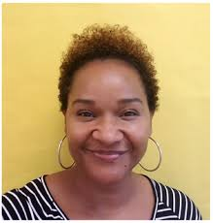
Lastly, I leave you in phenomenal hands. Mrs. Maurislyn Green, has been a Black Student Achievement Program(BSAP) Liaison for 5 years supporting both Glenelg and Marriots Ridge high schools. She will now split her week between Glenelg and Mt. Hebron. We will plan a virtual meet and greet before the last day of school. Mrs. Green has both served as my mentor when I moved from working in elementary schools to high schools and has become a dear friend. Therefore, it is with great confidence that I say, you are in great hands and we are working together to ensure this transition is a smooth one. In closing, my email address remains the same. Feel free to reach out to me with questions, concerns or just to say hi this summer or beyond. Remember, as you always hear Dr. Miller say, once a Viking, always a Viking.”

OFFICER DICERBO
Thank you Officer D. for all that you have done for our Hebron Community! We will miss you greatly! Your dedication to our students and staff is much appreciative. From your education classes, summer mentor program, our Student Safety Committee and your accessibility to meet with students in need.
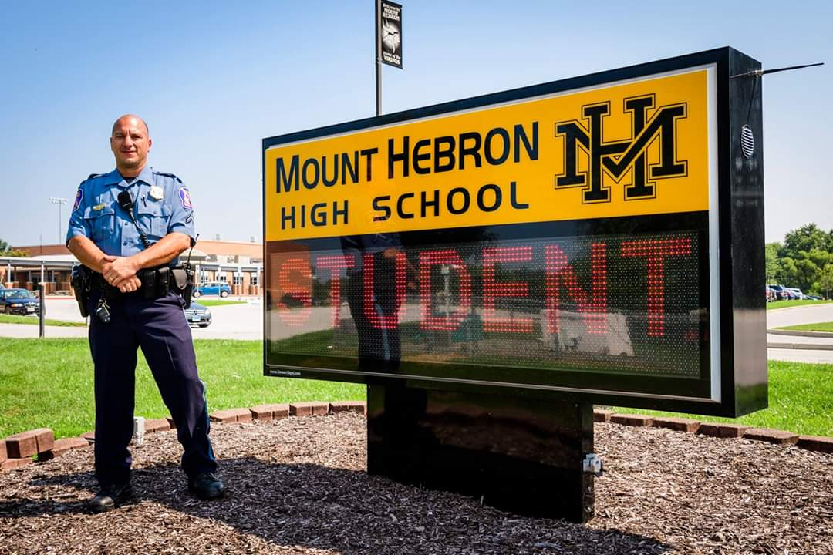
“It is with a heavy heart that I decided to leave the Mt. Hebron family. As most of you know I have been at Hebron for eight years and prior to that, two years and Homewood and two years at Howard. I have spent more than half of my law enforcement career mentoring our youth and being a part of their everyday lives. I have thought long and hard about this decision and I have submitted my paperwork to be transferred back to patrol. I have enjoyed seeing your faces every day as I stand on "my corner" and I will miss every single one of you. It has been an absolute pleasure working with all of you to shape the leaders of tomorrow (corny and not my style, but true). And for those that wish to keep in touch, some know how to get a hold of me, my email is jdicerbo@howardcountymd.gov. I look forward to crossing paths again, hopefully not on a traffic stop. Until then, take care.”

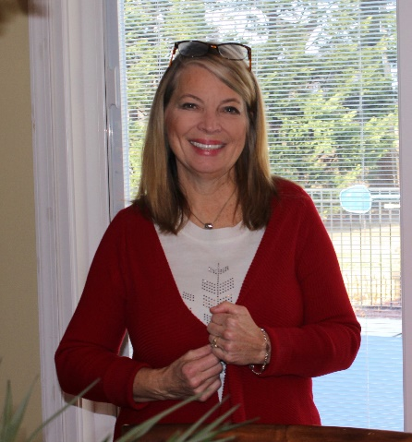
LINDA MATHIAS
Linda Mathias has been our Student Services Secretary for the last 17 years and has worked in HCPSS for twenty-five years.

Ms. Mathias shares,
“I have made amazing friendships and everlasting memories with students, parents and staff.
I plan on pursuing my hobbies in (finally) traveling, reading and history.
Mt Hebron HS !! you will be tremendously missed!”

JOSHUA ERNST

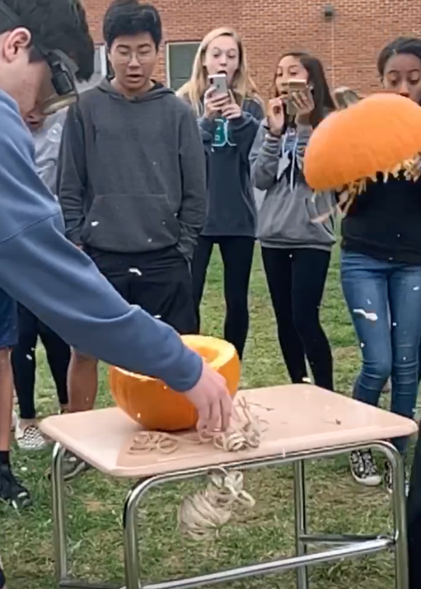
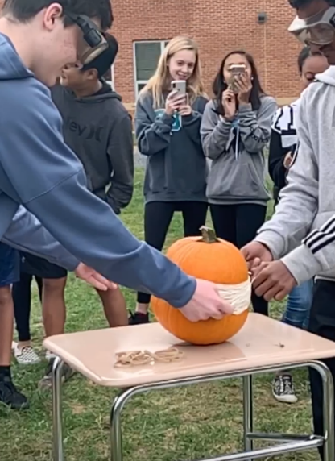
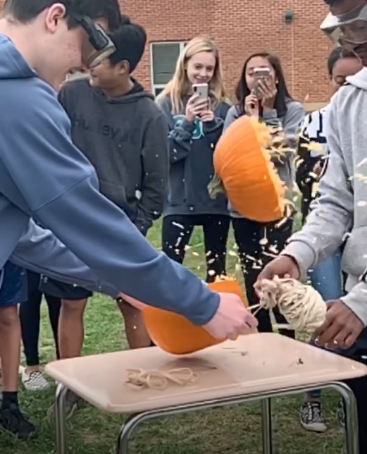
For those of you that don’t know me, I had the privilege of being one of Mount Hebron’s math teachers, this year. Prior to that, I taught martial arts for the majority of my high school and college years. I loved interacting with my students, and I knew that teaching was my future. So, when I was placed at Mount Hebron HS, I was ecstatic!
My colleagues’ welcoming arms were the first sign that I was going to like it at Mount Hebron. With a department as collaborative and genuine as mine, it’s hard not to feel like I am a part of something special. For them, I am very grateful.
Further, my experience with my students has been a pivotal step in my personal and professional growth. Though many of my ideas were ambitious and untested, I feel beyond lucky to have been matched with my wonderful students that were always as supportive of me as I tried to be to them. Teaching is by no means easy. But, it becomes much easier, and certainly worth it, when the students are as compassionate, quirky, and courageous as mine.
Next year, I’ll be journeying to another school to continue my growth as a teacher and aim to continue making positive impacts on my students’ lives. Although I won’t be at Hebron, I am excited to spread a little bit of the Viking Spirit to other schools. I won’t be far, though, because it’s true: “Once a Viking, always a Viking”.

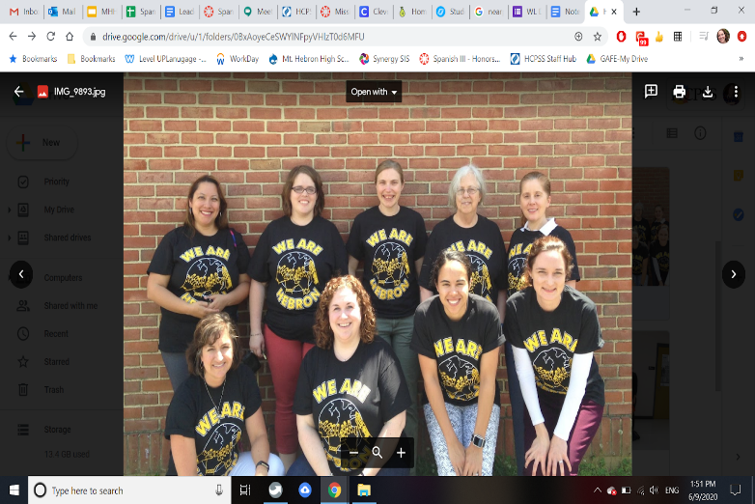
JUSTINE HUGHES
Justine Hughes has been a vital part of our team for a decade. She helped to grow our French program to two-full time staff members and to inspire a love of the French language and culture in our Viking community. We are so sad that she is leaving us, but we are so grateful that this is simply a "see you later" and not a "goodbye". We wish you well in your next position and are excited to hear about everything that your future brings!

LYDIA KANG
To the Mt. Hebron Family-Thank you. I started my teaching career at Mt. Hebron 4 years ago and learned so many things about what it takes to be an educator. What I didn’t expect was how much the relationships with my students would mean to me. To my students, both current and former, you are important, you are loved, and you’re going to make this world a better place in both big and small ways. I cannot wait until our paths cross again. Until then, know that you will always have a person who is rooting for you and who is thinking about you.
Starting this fall, I will be teaching at Girls Global Academy, a public charter school in Washington D.C., dedicated to raising young female leaders in the STEM field. I will miss so many of you, and what I really just want to convey is how grateful I am to have had you in my life and to have had so many people show me how to be a better teacher. That’s all I really want. And so as difficult as it is to leave this community that’s been everything to me, I move forward with the hope that I can continue to serve my students in the best way I can.

JOELLE BIELE
Joelle Biele has been teaching English for over 25 years. In addition to teaching at Mt. Hebron and Atholton high schools, she has taught at the University of Maryland, Goucher College, Johns Hopkins University, and UMBC. She was a Fulbright professor in Germany and Poland, taught middle schoolers at Johns Hopkins’ Center for Talented Youth, and tutored teenage girls in the Afghan Women’s Writing Project. She loves helping students’ reading and writing skills grow.
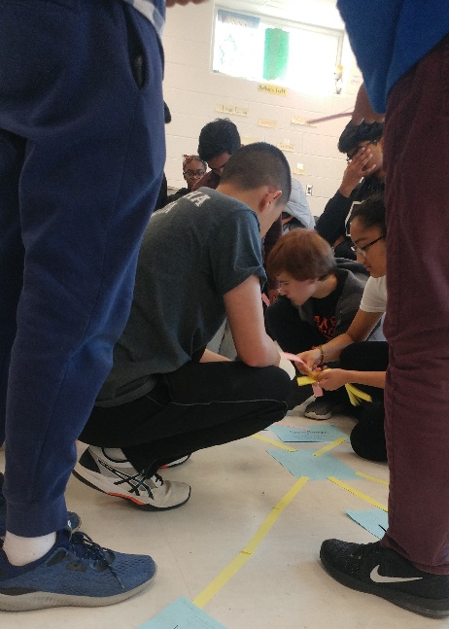
She shares, “I had lots of fun with my 10th graders this year. One of the things I’ll remember most are our community circles, debating whether or not a Pop Tart is a ravioli and sharing if we put on both socks and then our shoes (sock, sock) or if we put on sock-shoe, sock-shoe. My students were up for just about anything, whether it was tossing around a ball while reading Shakespeare, creating Lego towers to practice grammar, or making concept maps on the floor. I learned so much from their poems and collages, their videos and blogs. My students were a delight, and I’ll miss seeing them and my wonderful English department colleagues next year.”
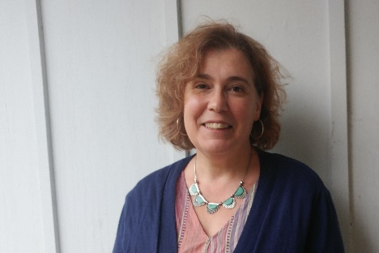
Dr. Biele was born in the Bronx and grew up in the New York area, the Chicago suburbs, and Baton Rouge, Louisiana. She received a B.A. in English from Tufts University, an M.F.A. and Ph.D. in English from the University of Maryland, and an M.A.T. from Johns Hopkins University. As her family says, she really likes school. In addition to being a teacher, Dr. Biele is also a poet, essayist, and playwright. The recipient of grants and awards from the Maryland State Arts Council and the Poetry Society of America, she has published books of poems and literary criticism and edited the poet Elizabeth Bishop’s letters with The New Yorker. Recent work has been work has been performed at Harvard University, the University of Chicago, and UCLA. While researching her latest book, she spent a lot of time in libraries reading late nineteenth-century newspapers so she could write about women tramps. She started making books when she was four. Cats were prominently featured. Dr. Biele lives in Ellicott City with her husband, three kids, and dog. Her bag is always packed with books, paper, pens, and Twizzlers. She was proud to be a Viking for the 2019-2020 school year.

JACQUELINE SICA
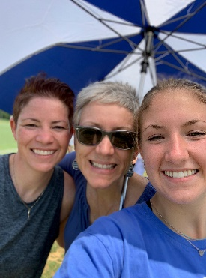
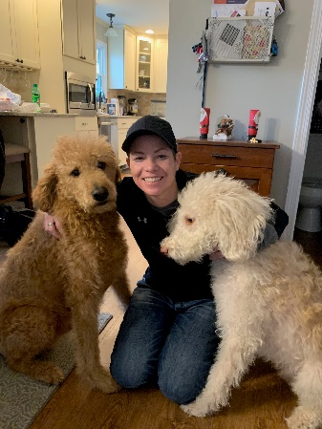
Jacquie Sica, our Administrative Intern, taught health education in middle school for the past 19 years, she was a Related Arts Team Leader and an acting Assistant Principal while at Burleigh Manor Middle School. While at Hebron she was an integral member of our SST team and worked closely with our Hispanic students. She monitored our master attendance during our distance learning and worked with staff checking in on our students. She will now be the Administrative Intern at Lake Elkhorn Middle School. She shares, “Thank you for allowing me to be a part of the Mt. Hebron community this year! Your passion for education and for what it means to be a Viking shines through and through with everything you do. I look forward to applying the skills I've learned here at Mt. Hebron in my future assignments. I wish you all a safe and healthy summer!”

NEW NEWS
Administrative Changes for 2020-21 School Year
Please join me in congratulating and saying good-bye to our Administrative Intern, Ms. Jacqueline Sica who will be transferring from Mt. Hebron High School to Lake Elkhorn Middle School. Ms. Sica joined our Administrative team in the fall and was an invaluable asset. LEMS will love having her and we will miss her greatly!

We would also like to welcome back our Administrative Intern, Mr. Jonathan Dupski! He left us midyear to work with the administrative team at Bonnie Branch MS. Welcome home Mr. Dupski!!!! He is elated to bring his skills as an educational leader back to MHHS and work with us as a partner in education to ensure the success of all students.

2020 Virtual National Student Council Conference
NASSP is inviting ALL Students to Rise Up and Lead. Join schools nationwide July 22–24 for the virtual National Student Council Conference. To ensure the first-ever virtual National Student Council Conference is the best possible experience for students, advisers, and all participants, this year’s dates are shifting to July 22–24. The new time frame allows NatStuCo to carefully craft this unique leadership experience—and it gives your students time to register for this FREE online event. They do not have group registration for this conference—students are welcome to sign up on their own or advisers can register their students individually.

Voices for Children 5k & Fun Run 11th Annual Race
Voices for Children 5k and Fun Run’s 11th annual community race is coming up this Labor Day weekend. This year, we are hosting a virtual race due to the pandemic. However, it is still going to be awesome! When registering, you will receive a T-shirt, Voices for Children goodies, and entered into some great giveaways. We encourage people to register and share their 5k run on social media. Our Instagram is @voicesforchildren5k and our Facebook is Voices for Children Howard County.

You’ve always supported us in the past and really made a difference. We ask that you register and spread the word about the race to your friends and family.

Register or donate at voicesforchildren5k.com. Thank you for your unwavering support and stay safe.

From our team at Hebron,

Haley Kampert, rising senior
Ashley Unkenholz, rising senior
Sophia Hogle, rising junior
Kirsten Prox, rising junior
Gwyneth Holzman, rising junior
Mira Tadimalla, rising junior
Abigail Fuller, rising sophomore
Reese Collins, rising sophomore

The Yearbook Needs YOUR PICTURES!!
Thank you to everyone who has submitted photos to the yearbook! The staff still needs your help with completing the 2020 yearbook. Here's how you can help:
-Everyone: Submit photos from Winter break and your life at home this spring! Are you still working? What does distancing learning look like for you? How are you staying in touch with your friends? Let us know by sending pictures and completing this survey! https://docs.google.com/forms/d/e/1FAIpQLSeNuPtnZstRYJU_awzb5xzXvaElA2ehuoWYd6eD-Sd69cOpSg/viewform

Here is how you can submit:
-Download the Jostens ReplayIt! App in your app store. Here's a brief video of how it works: https://youtu.be/DxM4h29GYjY?t=22

DIPLOMA COVER MAKE UP DAY
- Did you miss the chance to pick up your diploma OR diploma cover? The last chance to pick them up is TUESDAY, JUNE 16 from 9:30-11 in the Student Parking Lot. Any family member is able to pick up the diploma cover; only you or a parent can pick up the diploma. We have limited access to the building and will not be able to offer an additional date in June. See you Tuesday!!
SUMMER SAT PREP BY THE ANSWER CLASS
- Is Your College-Bound Student Taking the SAT or ACT Soon?
Comprehensive and Convenient Summer SAT Prep for Mt. Hebron HS students
M/W June 29 & July 1 from 9:30 am – 1:30 pm
OR
M/W July 27 & 29 from 5 pm – 9 pm
Our live virtual, eight-hour SAT and ACT classes are open to area high school students looking for comprehensive, convenient, and engaging summer test prep.
Summer is the perfect time to enroll your student in The Answer Class’s affordable online test prep. Learn everything you need to know about the SAT in only 8 hours – and without breaking the bank!

Students and parents can easily register for these classes on our website and the needed materials will either be mailed to your home or sent by email to print at home. Students will also receive a link to join the online classroom.

NEWS WORTH REPEATING

Great Resource for Families
Columbia Cares is an organization that has helped many families throughout the region with food and other household items. There are distribution sites at several of the HCPSS grab and go sites for those families with transportation, or an opportunity to have groceries delivered for those without transportation or in quarantine. Feel free to look at the website for information on the organization as well as opportunities for volunteering or monetary support/ ways to connect your families to distribution sites or grocery delivery. They speak Spanish too! Feel free to reach out to Diann with questions! http://columbiacare.live/about-us/

National Honor Society Update
Attention all juniors and seniors. The NHS application deadline has been moved to September 30, 2020. Please do not submit your teacher recommendation forms via email at this point. Please hold all application materials until next fall. Questions can be directed to Mary_Sankey@hcpss.org or Suzanne_Stafford@hcpss.org
Looking for Donations of Photo Supplies
Many people are finding time to do some extra cleaning and organizing these days. If you have any old film cameras or photography equipment you don't use any more, please consider donating it to the MHHS art department for our photography classes. Email instructor Caroline Creeden caroline_creeden@hcpss.org

Are You A Proud Viking? Become A Viking Backer!
We invite you to join the Viking Backers, Booster Club for Mt. Hebron High School. The Viking Backers is an all-volunteer, parent organization which supports ALL student extracurricular activities including academics, arts & athletics.

Visit www.vikingbackers.org to join online. We no longer are taking paper forms or checks; everything is going through the website. Your membership supports ALL students at Mt. Hebron.

