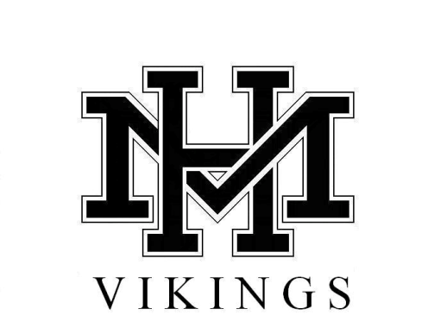
PRINCIPAL’S NEWSLETTER
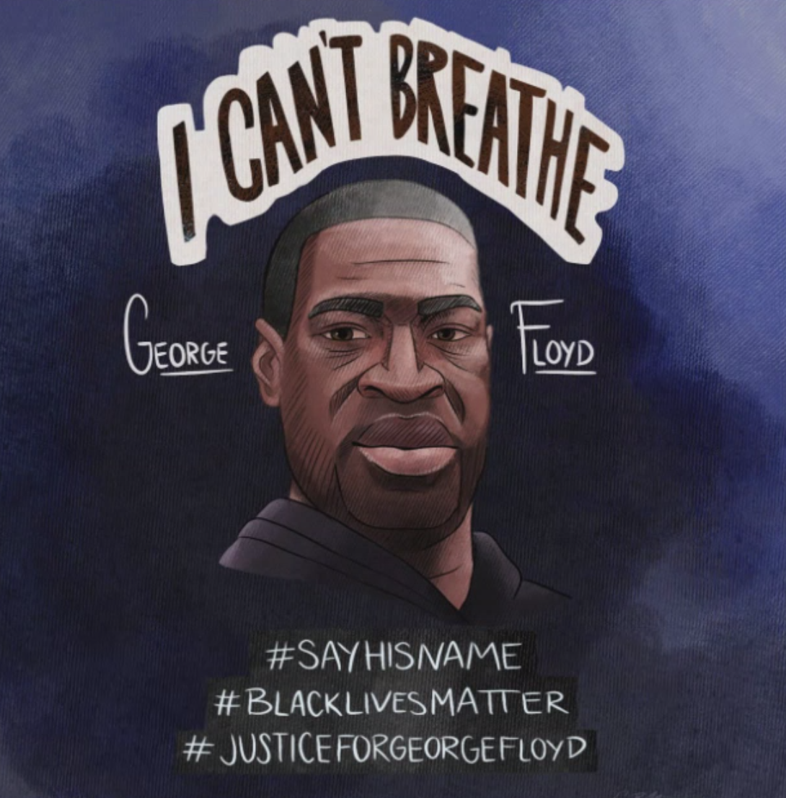
June 5, 2020

THANK YOU to CLARE MANSOUR for sharing her talent and her heart through this truly incredible artwork. A picture is worth more than a thousand words.
Until next week, stay safe. Stay Connected. Stay hopeful. And, of course, stay Viking Strong. ~Joelle
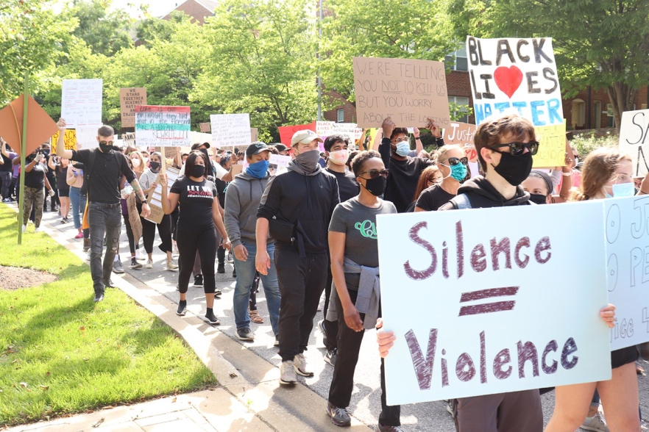

On Tuesday, a group of black and brown Howard County youth organizers came together to mourn the deaths of George Floyd, Breonna Taylor, Tony McDade, Ahmaud Arbery, India Kager, and the countless other lives lost at the hands of police brutality. This youth collective, under the name of HoCo For Justice, organized a march and vigil in Columbia to condemn police brutality, white supremacy and violence against Black lives. The two co-organizers, Sara Wunete and Sara Chernikoff, are alumni of Mt. Hebron High School. As vocal advocates for education reform in Howard County, they organized the 2016 Mount Hebron Walkout and along with other students formed DREAM (Diversity Reaching Everyone Across all Minds) Team, a student led activist organization. DREAM Team utilized their platform to push for discriminatory policy reform, the increase of educators of color in the school system, and the addition of courses that support wider cultural perspectives within the school curriculum.

As a result of their education and troubling experiences at Mt. Hebron, Wunete and Chernikoff have equipped themselves with the knowledge and tools to organize for change. They were able to contribute to the youth collective, Hoco for Justice, by building a platform and supporting those silenced by the injustices they face.

The two activists used their experience and knowledge to help organize the march/vigil and put out a call to action aimed towards Howard County residents. They are continuing to advocate for racial justice both in schools and in the community. Their call to action includes supporting the missions of Racial Justice Now, Dignity in Schools Campaign and the Advancement Project. These three organizations are working towards ending the school to prison pipeline. They are also calling on Howard County residents to support two grassroots organizations that are working towards preventing gun violence in Baltimore; Baltimore Ceasefire and Good Kids Mad City. Wunete and Chernikoff urge Mt. Hebron community members to join the youth collective’s mission by supporting and protecting Black lives. For more information on how to get involved, visit: www.HocoForJustice.com

The NAACP is calling for 8 minutes and 46 seconds of silence today, the day of George Floyd's funeral, at 3:45pm.
To honor this, we are moving our Let's Come Together Google-Meet to 2:45 pm today instead of 3:30.

Congratulations to all of our seniors! We hope you enjoyed your commencement ceremony. If you missed it, you can view it here:

https://www.hcpss.org/commencements/mhhs/

A special THANK YOU & SHOUT OUT to our graduation organizers for all of their hard work: Ms. Engelstatter, Ms. Gutierrez, Ms. Miles and Ms. Rocheleau.
FOLLOW US & STAY CONNECTED
Twitter: @hcpss_mhhs
Website: http://mhhs.hcpss.org
Student Online Newspaper: The Mountain: https://mthmountain.com
UPCOMING DATES/EVENTS
Date | Time | Event
June 10 |  | Student Materials Drop-off
June 11 |  | Virtual Student Visit Day for Rising 9th Graders
June 12 |  | Virtual Student Visit Day for Redistricted 10th-12th graders
June 18, 21 & 22 |  | Half days for students
June 23 |  | Last Day of School for students

CELEBRATIONS!
**For even more celebrations & good news, follow us on Twitter: @hcpss_mhhs

THANK YOU to Kelsey’s Restaurant in Ellicott City and CONGRATULATIONS to the Class of 2020 who won Kelsey’s Grad--fiti promotion!!

The award is $2020 and it will be applied to the program of the school’s choosing in honor of the name, "CLASS OF 2020."

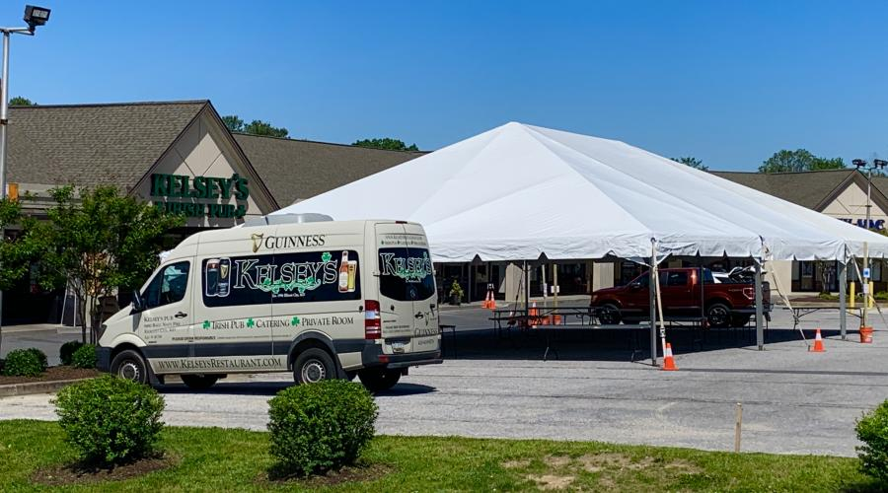
The seniors will also be able to "name" one of KELSEY’S menu items for the next year.

This was such a great promotion that the restaurant is considering running it every year!!

Kelsey’s manager says that it was great to meet the kids, hear about their plans, and just connect and give them a reason to smile and feel a part of their school spirit!!

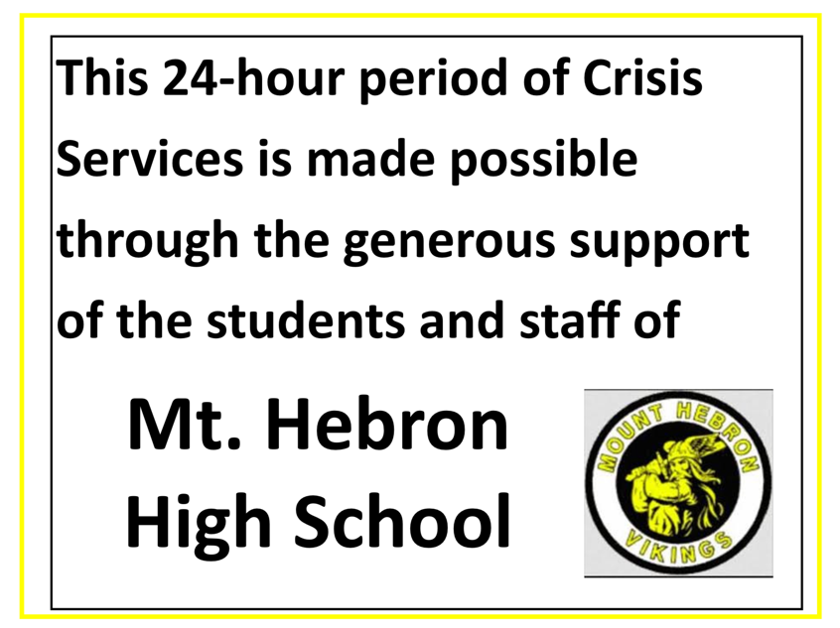
THANK YOU to Ms. Tagget & everyone who donated to our MHHS Crisis Support Day May 20, 2020. Here’s the sign that is posted at Grassroots. We raised $1,302.87 this year during Pi Week. Ms. Tagget’s daughter's foundation, the Katrina Tagget Memorial Foundation, donated $1,097.13 so that MHHS donation to Grassroots totaled $2,400 to pay for 24-hours of support. Thank you for continuing to support MHHS Pi Day Buy a Day. We are doing good work for our community!
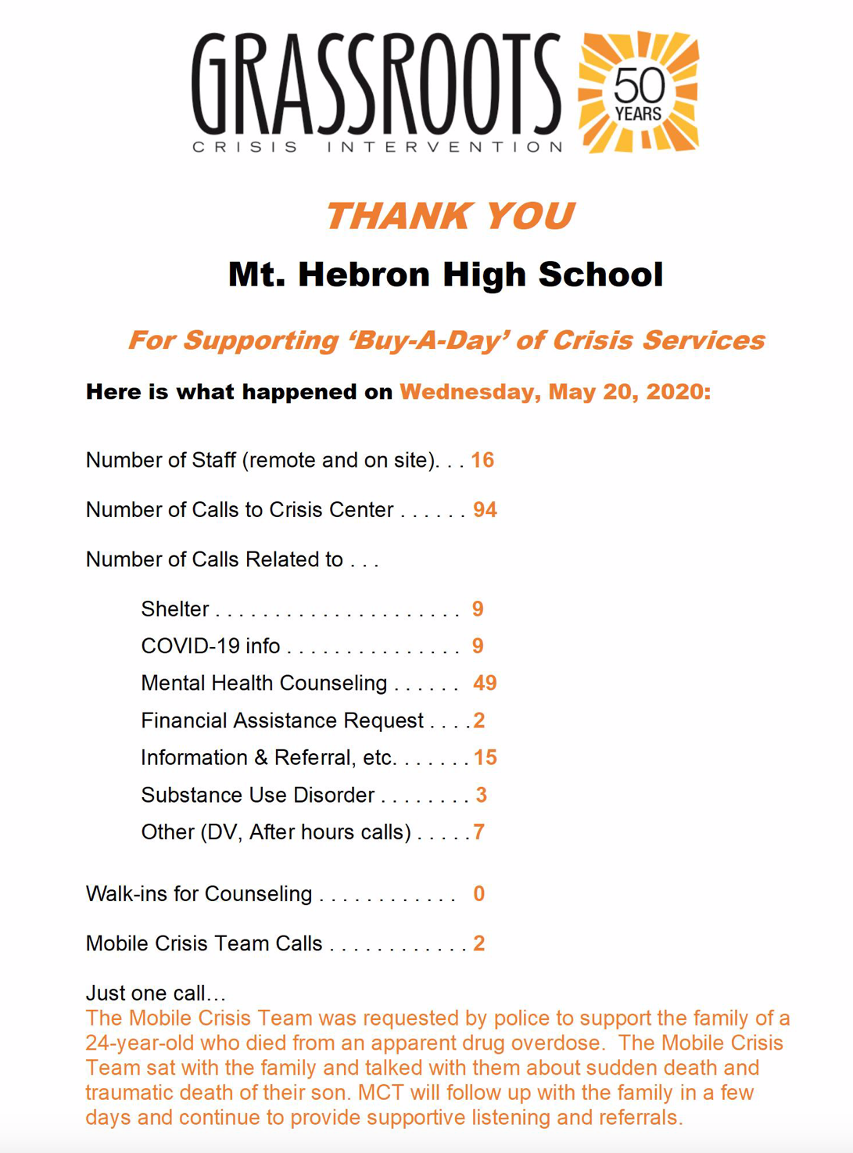

Two of our incredible staff members are retiring this year. We are so thankful for all they’ve done for our students and Hebron community.

John M. Klyap, School Psychologist
Mr. Klyap has been our School Psychologist for ten years at Mt. Hebron. He has worked in HCPSS for thirty years.
Mr. Klyap shares, “It has been a pleasure and an honor to work with all the amazing students, parents and staff in our community. I can’t imagine a better place to work and live! My best wishes to the Mt. Hebron community for a healthy, happy, and prosperous future! I will miss all of you!”

Our incredible art teacher, Ms. Mary Kate Hannah, always brings out the very best in our student artists as she nurtures their abilities and brilliance.

Mary Kate Hannah has been an art teacher for 33 years. In 1997 she landed her dream teaching job at Mt. Hebron High School, where she has remained for 23 years teaching Art I, II, III, AP Studio Art and darkroom photography.
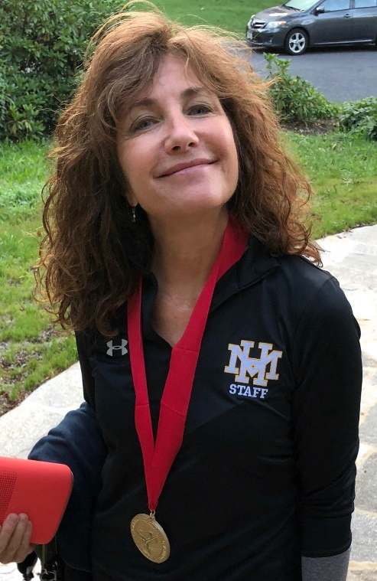
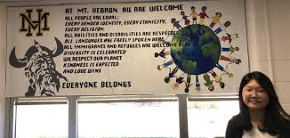
In addition, she is the faculty sponsor of the National Art Honor Society, and the Art Club. She proudly represents the faculty of Mt Hebron for the Howard County Education Association, where she is an activist and lobbyist for teachers' and students' rights.
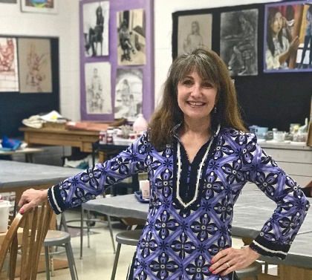
Ms. Hannah was recognized with the National Art Educator Award from the Scholastic Art and Writing Competition in 2018. Her first year teaching in Howard County she was recognized with Howard County’s new art teacher of the year award.

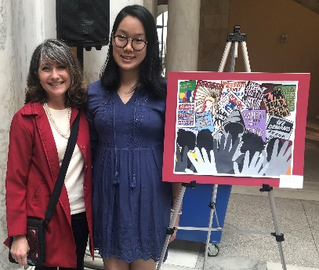
Her proudest teaching moments are when her art students were honored with first place from U.S. Congressional Art Award Competition in 2014, 2016, 2018, and most recently in 2019. These MHHS students’ artworks were displayed on the walls of the U.S. Capital Building, as well as the Walters Art Museum, Baltimore Museum of Art and Carnegie Hall in New York City.

Many of her former students continue to have won art scholarships to the Art Institute of Chicago, Md. Institute College of Art, California Institute of the Arts, Rhode Island School of Design, School of Visual Arts in NYC, Pratt Institute, The Cooper Union, Carnegie Mellon University, Pennsylvania College of Fine Art, Pacific Northwest College of Art, Savannah College of Art & Design and Ringling College of Art and Design.

Ms. Hannah was born and raised in Baltimore. She started her public school teaching career in 1987 after receiving a Bachelor of Fine Arts degree from St. Mary’s College of Maryland as well as Masters degrees in Photography and Secondary Art Education from Towson University.

Ms. Hannah and her husband of 37 years raised three sons in Catonsville, MD. Two of her sons are also public school teachers. Ms. Hannah is a working artist and will continue to pursue her other dream job as an artist and photographer. Her favorite subjects to paint are animal portraits and scenic landscapes. She enjoys family time, black and white darkroom photography, bicycling, hiking, kayaking, water sports, live concerts, dancing, travel, and outdoor cafes.

To say that we will miss her is an understatement.

NEW NEWS
Voices for Children 5k & Fun Run 11th Annual Race
Voices for Children 5k and Fun Run’s 11th annual community race is coming up this Labor Day weekend. This year, we are hosting a virtual race due to the pandemic. However, it is still going to be awesome! When registering, you will receive a T-shirt, Voices for Children goodies, and entered into some great giveaways. We encourage people to register and share their 5k run on social media. Our Instagram is @voicesforchildren5k and our Facebook is Voices for Children Howard County.

You’ve always supported us in the past and really made a difference. We ask that you register and spread the word about the race to your friends and family.

Register or donate at voicesforchildren5k.com. Thank you for your unwavering support and stay safe.

From our team at Hebron,

Haley Kampert, rising senior
Ashley Unkenholz, rising senior
Sophia Hogle, rising junior
Kirsten Prox, rising junior
Gwyneth Holzman, rising junior
Mira Tadimalla, rising junior
Abigail Fuller, rising sophomore
Reese Collins, rising sophomore

The Yearbook Needs YOUR PICTURES!!
Thank you to everyone who has submitted photos to the yearbook! The staff still needs your help with completing the 2020 yearbook. Here's how you can help:
-Everyone: Submit photos from Winter break and your life at home this spring! Are you still working? What does distancing learning look like for you? How are you staying in touch with your friends? Let us know by sending pictures and completing this survey! https://docs.google.com/forms/d/e/1FAIpQLSeNuPtnZstRYJU_awzb5xzXvaElA2ehuoWYd6eD-Sd69cOpSg/viewform

Here is how you can submit:
-Download the Jostens ReplayIt! App in your app store. Here's a brief video of how it works: https://youtu.be/DxM4h29GYjY?t=22
-Email photos to the yearbook at yearbook.mounthebron@gmail.com please identify people in the photos with names and grades as well as a brief description of what the photo is about.

Questions? Email Ms. Fischetti at lauren_fischetti@hcpss.org

There's one last chance to order your 2020 yearbook! After selling out, we have increased our book numbers--only 15 remain! Order by Friday, June 12 to secure your 2020 yearbook! Order directly from: https://www.jostens.com/apps/store/productDetail/1066901/Mount-Hebron-High-School/Yearbook/2020060504151848076/CATALOG_SHOP/YB_BOOKS/Yearbook/2020060504151849376/#design/0
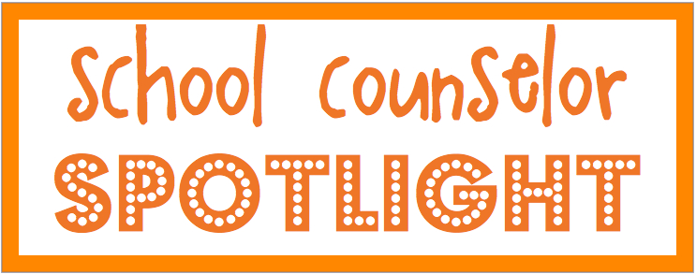

POST-SECONDARY PLANNING SERIES
- The Athletic Recruiting Process
Location:
The recorded presentation will be posted on your Student Services canvas page.
- The Benefits of Attending A 2-year College
Date: June 4, 2020
Time: 3:00pm
Location:
The recorded presentation will be posted on your Student Services canvas page.
- Telling Your Story
Bailey Jackelen,
Assistant Director, Johns Hopkins University
Date: June 11, 2020
Time: 7:00pm
Location: Event registration link (you will receive the log in information in the event confirmation)
https://admissions.jhu.edu/register/hcpsworkshop

VIRTUAL COLLEGE VISITS
- Bates College is offering virtual tours and information sessions with admissions reps. You can find out more about Ms. Valentine’s Alma Mater on their website! BATESINFORMATION
- Carnegie Mellon invites you to virtual admissions counseling sessions, registration is required. Register for a session HERE.
- Coast to Coast College Tour – Includes University of California Berklee, Darmouth, Northwestern, Princeton and Vanderbilt! Registration is required. Visit the Coast to Coast Tour website for a full list of programs.

SALLIE MAE RESOURCES
Did you know Sallie Mae does more than just student loans? They have a series of workshops and resources available for FREE! Use “control click” to access the links.
How to Pay the Remaining Balance: Many students and families will consider financing a portion of their college education. The focus of this session will be on encouraging responsible borrowing and what students and families can do to find the right solution for their borrowing needs.

Wednesday, June 10: 1pm-2pm EST Register here
Thursday, June 11: 7pm-8pm EST Register here

Understanding the cost of student loan borrowing: This presentation covers financial literacy topics such as the relative cost of a student loan, loan repayment tools, and tips on managing student loans. It identifies important things students should know about their loan portfolio, identifying their servicers and understanding the cost of their student loan.

Wednesday, June 17: 2pm-3pm EST Register here
Thursday, June 18: 8pm-9pm EST Register here

NEWS WORTH REPEATING

Student Schedule for the remainder of the school year:
Format for Google-Meet: Nicknames for all google meet check-ins:
MHHS-TEACHER’S LOGIN ID-PD#-DATE

Teachers will have work for the week for you to complete posted in Canvas by 9:00 am on Mondays
Mondays: Period 4A Google Meet Check-In: 1:00-1:45 pm OR 2:00-2:45 pm
Tuesdays
- Period 1 Google Meet Check-in: 8:00-8:45 am OR 9:00-9:45 am
- Period 4B Google Meet Check-in: 1:00-1:45 pm OR 2:00-2:45 pm
Wednesdays
- Period 2 Google Meet Check-in: 8:00-8:45 am OR 9:00-9:45 am
- Period 5 Google Meet Check-in: 1:00-1:45 pm OR 2:00-2:45 pm
Thursdays
- Period 3 Google Meet Check-in: 8:00-8:45 am OR 9:00-9:45 am
- Period 6 Google Meet Check-in: 1:00-1:45 pm OR 2:00-2:45 pm
Fridays: Submit your work by 10:00 am
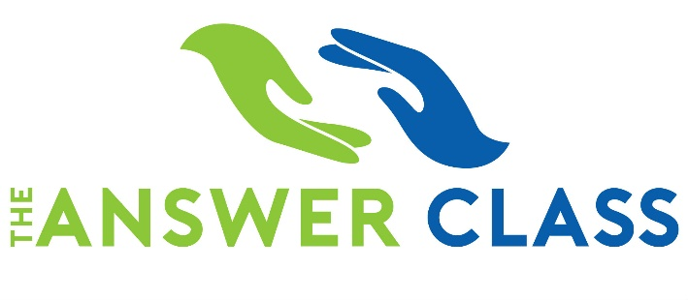
A VIRTUAL EVENING FOR PARENTS ABOUT THE SAT & ACT

Thurs., June 11 @ 7:00 pm  Online
Presented in Partnership with MHHS PTSA & Guidance Office
Please join us for a special evening to learn more about the SAT & ACT and how these important tests impact your child’s college application.
This complimentary session includes:
- Differences between SAT & ACT
- Tips and strategies on timing, guessing, and scoring
- Updates on summer & fall testing
- Helping your student decide which test better matches their strengths
- Question and Answer period

Join Zoom Here

----------------------------------------------------------------------------------------------------------------

Is Your College-Bound Student Taking the SAT or ACT Soon?
Comprehensive and Convenient Summer SAT Prep for Mt. Hebron HS students

M/W June 29 & July 1 from 9:30 am – 1:30 pm
OR
M/W July 27 & 29 from 5 pm – 9 pm
Our live virtual, eight-hour SAT and ACT classes are open to area high school students looking for comprehensive, convenient, and engaging summer test prep.
Summer is the perfect time to enroll your student in The Answer Class’s affordable online test prep. Learn everything you need to know about the SAT in only 8 hours – and without breaking the bank!

Students and parents can easily register for these classes on our website and the needed materials will either be mailed to your home or sent by email to print at home. Students will also receive a link to join the online classroom.

Great Resource for Families
Columbia Cares is an organization that has helped many families throughout the region with food and other household items. There are distribution sites at several of the HCPSS grab and go sites for those families with transportation, or an opportunity to have groceries delivered for those without transportation or in quarantine. Feel free to look at the website for information on the organization as well as opportunities for volunteering or monetary support/ ways to connect your families to distribution sites or grocery delivery. They speak Spanish too! Feel free to reach out to Diann with questions! http://columbiacare.live/about-us/

National Honor Society Update
Attention all juniors and seniors. The NHS application deadline has been moved to September 30, 2020. Please do not submit your teacher recommendation forms via email at this point. Please hold all application materials until next fall. Questions can be directed to Mary_Sankey@hcpss.org or Suzanne_Stafford@hcpss.org

Looking for Donations of Photo Supplies
Many people are finding time to do some extra cleaning and organizing these days. If you have any old film cameras or photography equipment you don't use any more, please consider donating it to the MHHS art department for our photography classes. Email instructor Caroline Creeden caroline_creeden@hcpss.org

Are You A Proud Viking? Become A Viking Backer!
We invite you to join the Viking Backers, Booster Club for Mt. Hebron High School. The Viking Backers is an all-volunteer, parent organization which supports ALL student extracurricular activities including academics, arts & athletics.

Visit www.vikingbackers.org to join online. We no longer are taking paper forms or checks; everything is going through the website. Your membership supports ALL students at Mt. Hebron.

